Sri Lanka Institute of Information Technology



Assignment 1

MLB_11.01_09

Online Teacher Trainer

**Internet and Web Technologies – IT1100**

B.Sc. (Hons) in Information Technology

**Group Details**

Group Number: MLB_11.01_09

Project Title: Online Teacher Trainer

|  |  |  |  |  |
| --- | --- | --- | --- | --- |
|  | **Student ID** | **Student Name** | **Email** | **Contact Number** |
| 1 | <<Leader’s Details>> |  |  |  |
| 2 |  |  |  |  |
| 3 | IT22144430 | Liyanage N S | it22144430@my.sliit.lk | 0765503048 |
| 4 |  |  |  |  |
| 5 |  |  |  |  |

# **Introduction**

<<Give a brief introduction about your project **[About half a page]**>>

# **Personas**

<<Use following format for all **5 personas**>>

* Example :Customer – Purchasing a book

|  |  |
| --- | --- |
| **Online Book Shop – User account Details** | |
| <<image>> | Name: Kamal Fernando |
| Age: 18 |
| Motivation: To learn HTML |
| Goals: Purchase books regarding HTML |
| Technical Ability: Professional at work with technology |

* 2nd Persona

|  |  |
| --- | --- |
| **<<Project Title>>** | |
| <<image>> | Name: |
| Age: |
| Motivation: |
| Goals: |
| Technical Ability: |

* 3rd Persona

|  |  |
| --- | --- |
| **<<Project Title>>** | |
| <<image>> | Name: |
| Age: |
| Motivation: |
| Goals: |
| Technical Ability: |

* 4th Persona

|  |  |
| --- | --- |
| **<<Project Title>>** | |
| <<image>> | Name: |
| Age: |
| Motivation: |
| Goals: |
| Technical Ability: |

* 5th Persona

|  |  |
| --- | --- |
| **<<Project Title>>** | |
| <<image>> | Name: |
| Age: |
| Motivation: |
| Goals: |
| Technical Ability: |

# **User Journeys**

<<Use following format for all **5 user journeys**>>

* Example: Persona-Customer User Journey-Purchasing a book

Login to the site

Search books

Land on the site via online advertisement

Confirm purchasing

Add payment details

* Persona- User Journey-
* Persona- User Journey-
* Persona- User Journey-
* Persona- User Journey-

# **Wire Frames**

* Home Page

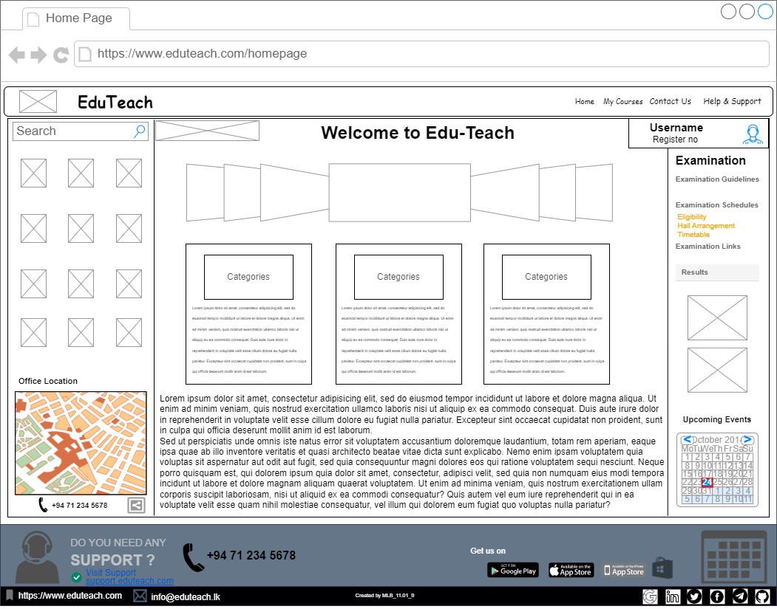

* Registration Page(Cover)

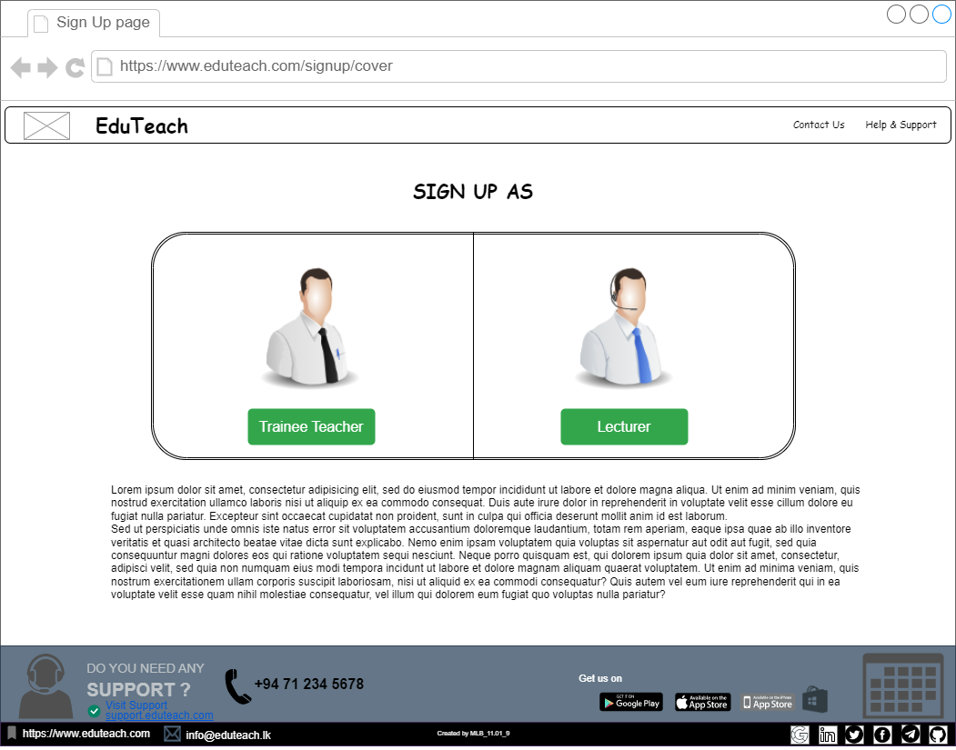

* Registration Page(Trainee Teacher)

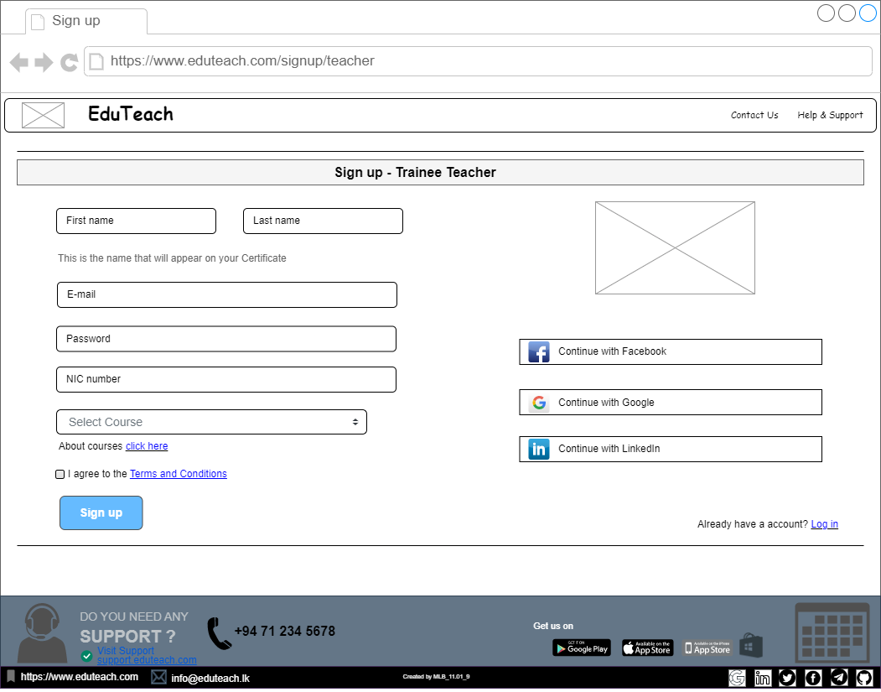

* Registration Page(Lecturer)

* Login Page

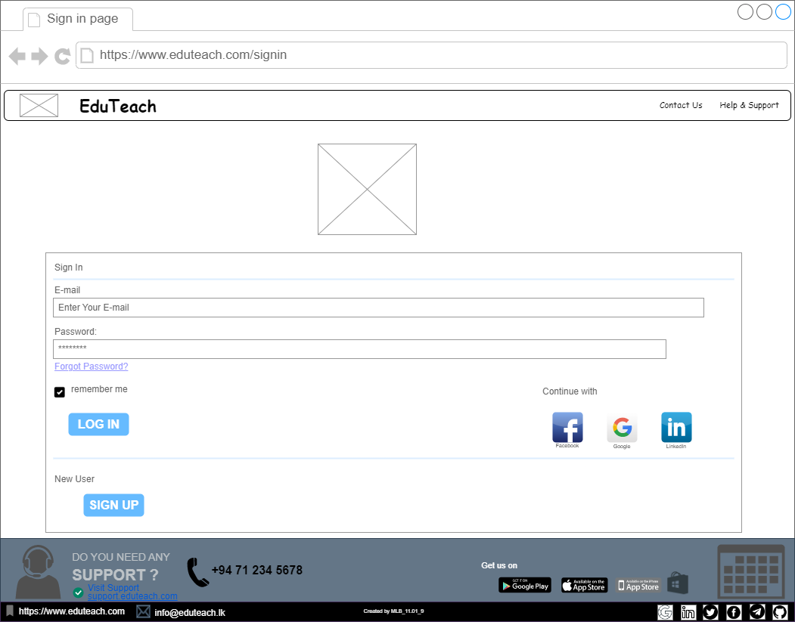

* Contact Us Page

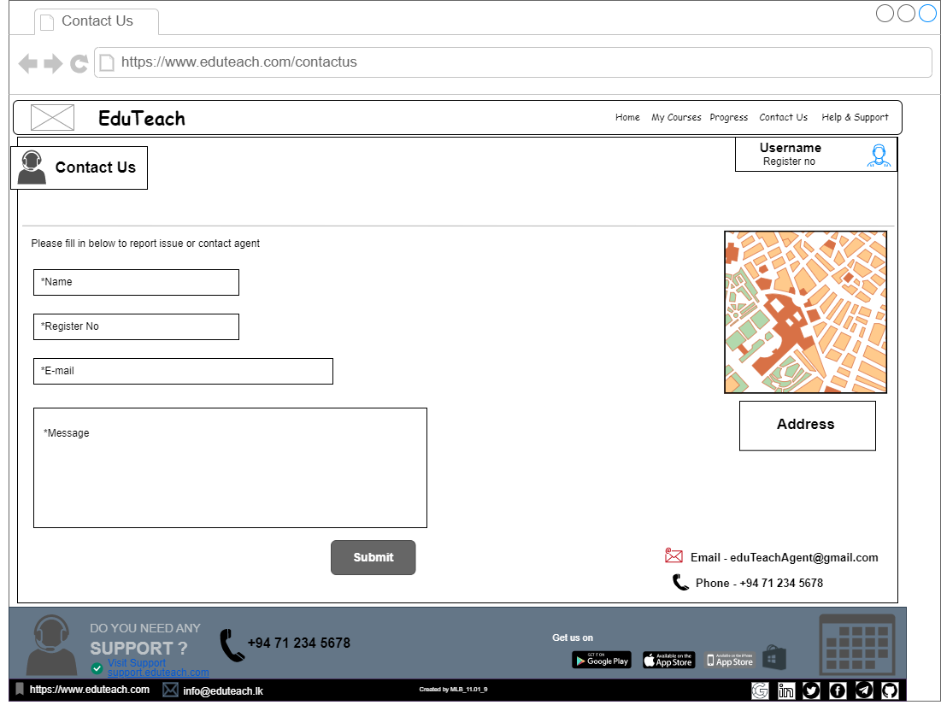

* User Account Page

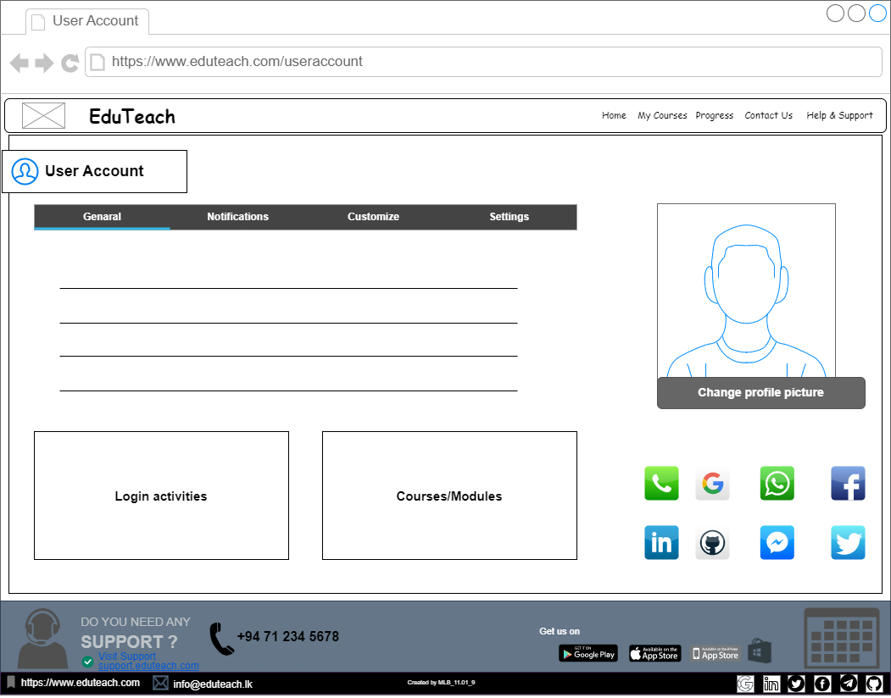

* My Courses Page

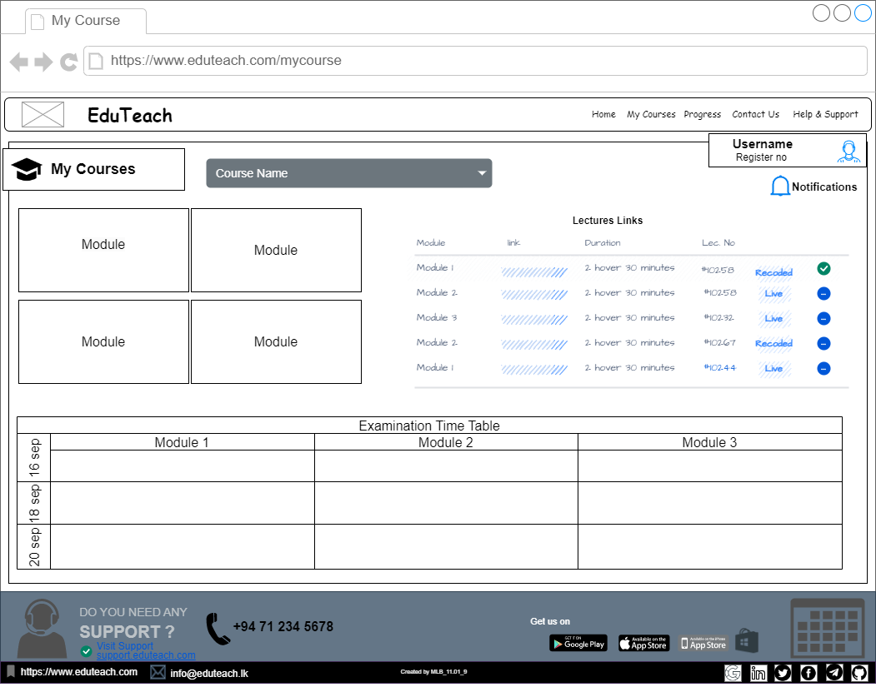

* Payment Page

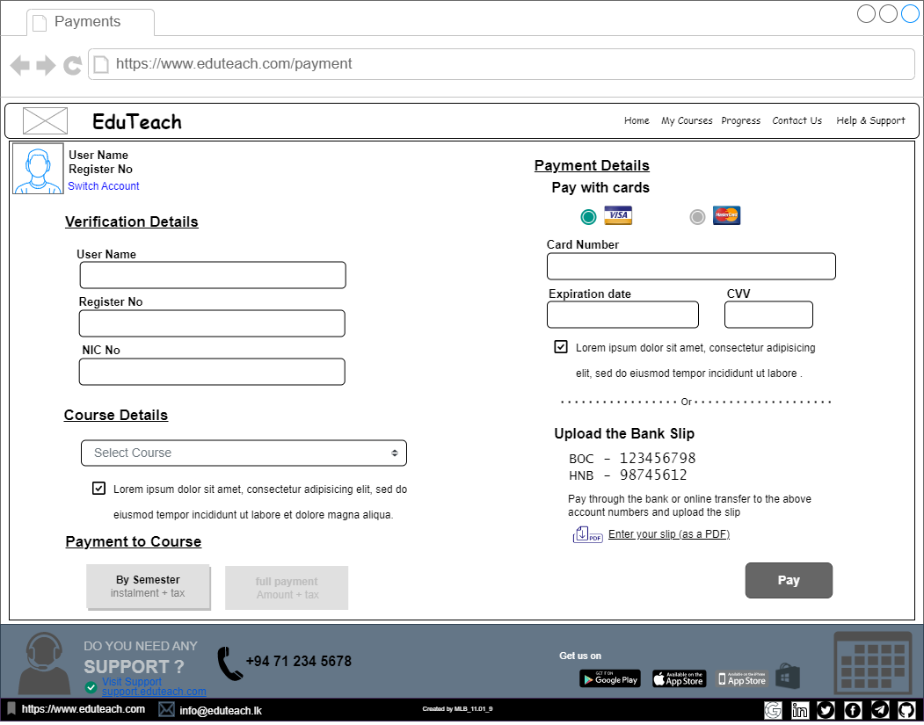

* Progress Page

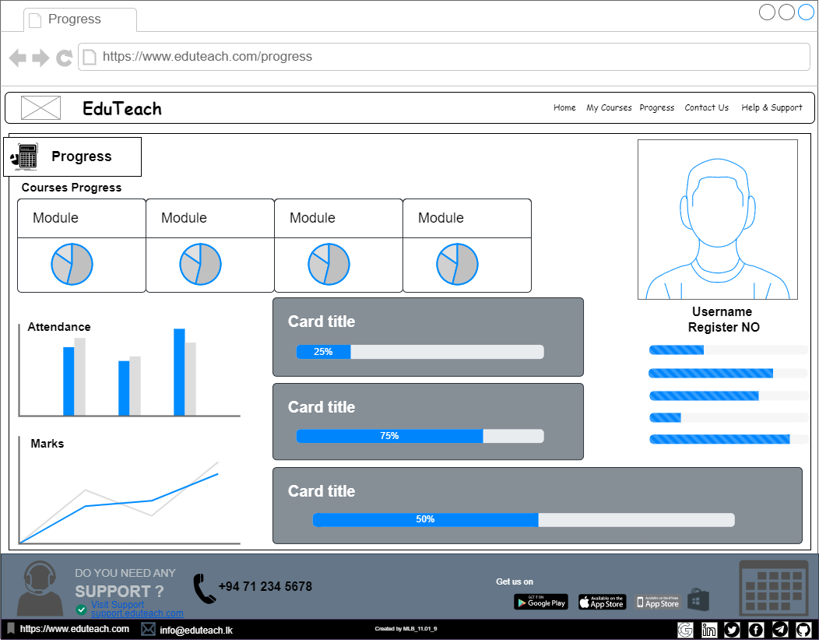

* Recorded Video Page

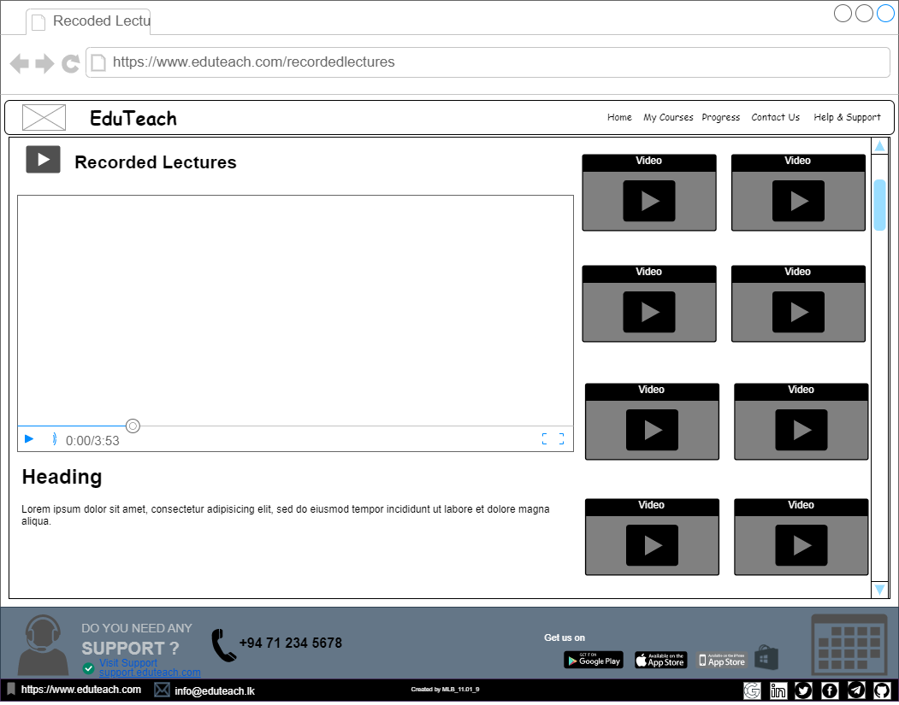

* About Courses Page

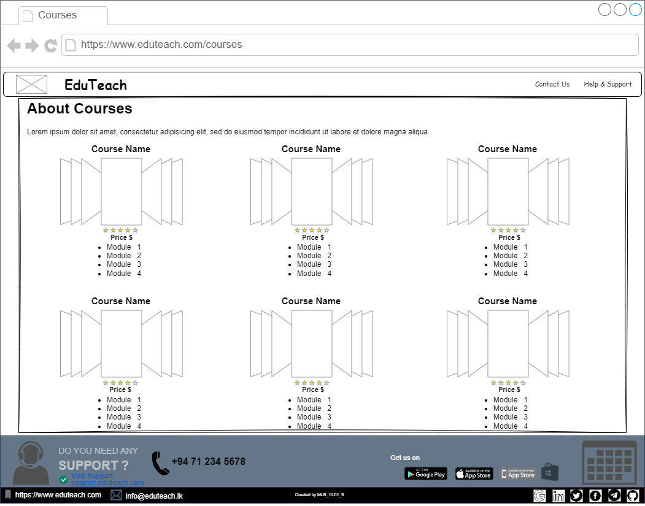

* Help & Support Page

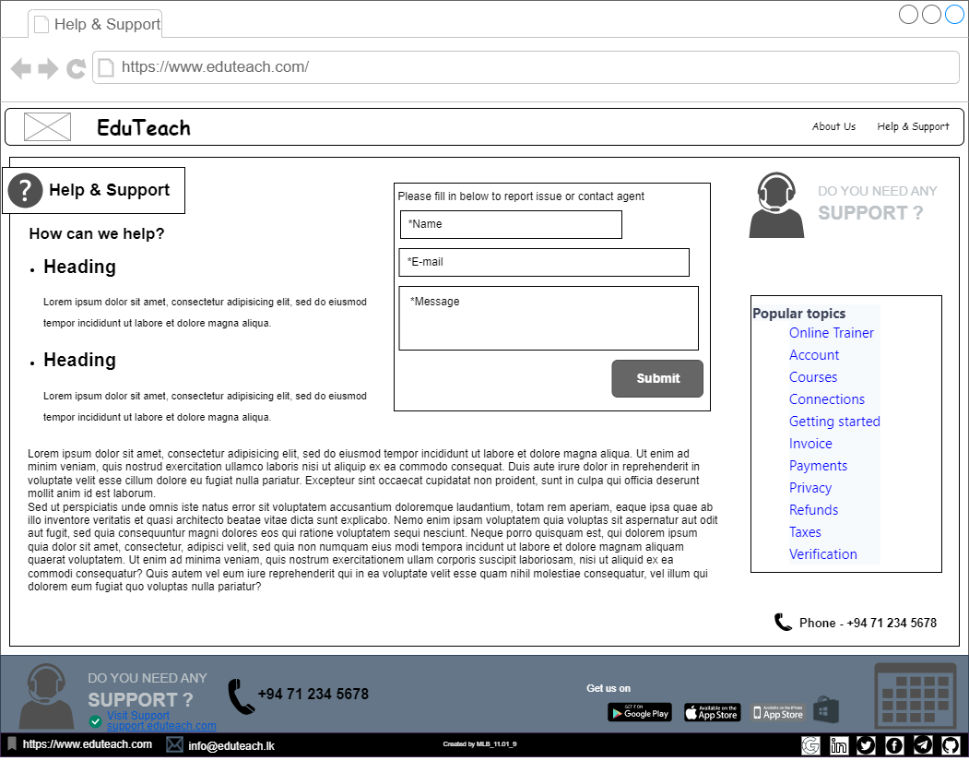

* About Us Page

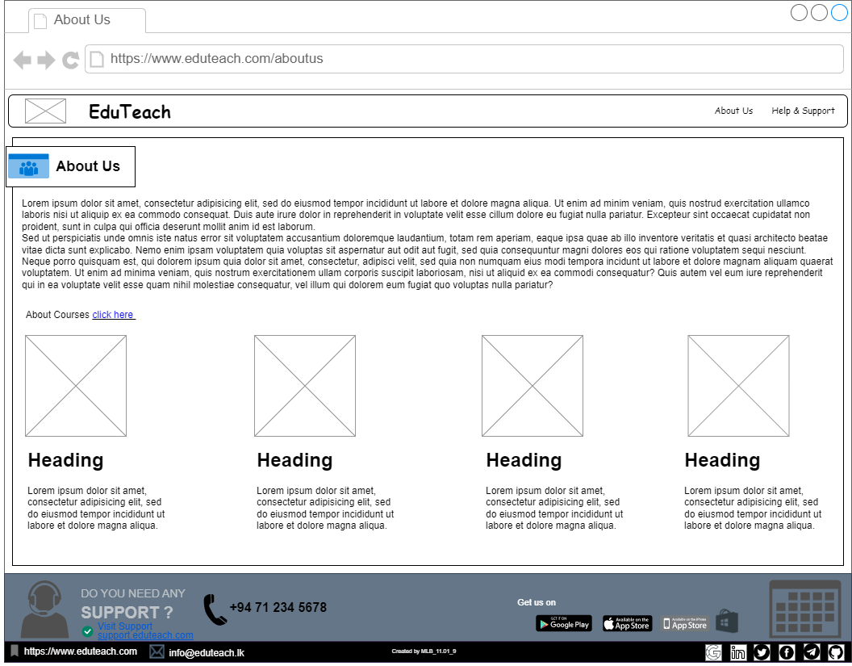

* Forgot Password Page

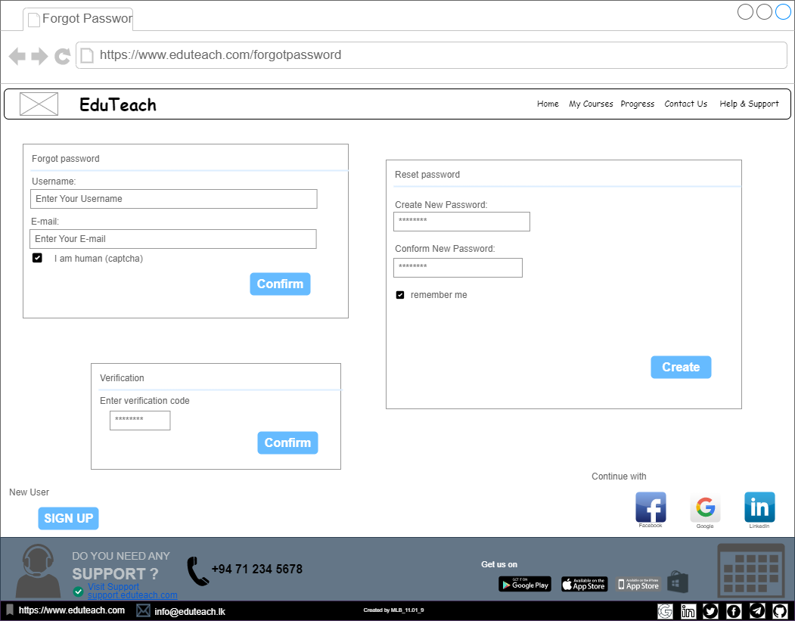

# **Individual Contribution**

|  |  |  |  |
| --- | --- | --- | --- |
|  | **Student ID** | **Student Name** | **Individual Contribution** |
| 1 | ITXXXXXX |  | * Persona: Customer Purchasing a book * User Journey: Purchasing a book * Wireframe: Home page |
| 2 |  |  |  |
| 3 | IT22144430 | Liyanage N S | * Persona: Unregister User Sign Up * User Journey: Sign Up * Wireframe:  1. Home Page 2. Sign up (Trainee Teacher) 3. Sign up (Lecturer) |
| 4 |  |  |  |
| 5 |  |  |  |

**<<IMPORTANT: Please upload the pdf format of your document only by one person from the group >>**